Everyday Life
Most Greeks organized their day by the amount of natural light available. Unless they were slaves or workers, men spent most of their waking hours outdoors. They got up at sunrise, and their day usually ended at sunset when they went to bed, unless there was a party
or a festival. Like people in other societies, the Greeks believed a deity controlled day and night. Helios [HE-lee-ahs], god of the sun, arose from the sea each morning. Helios rode
across the sky and returned to the sea at dusk, prepared to rise again the next day.
The city-state helped the Greeks meet their basic needs. It also provided recreation and entertainment in the form of athletic contests, plays, and religious festivals. Religion helped the Greeks make sense of the world around them by explaining events as the actions of the gods, while philosophers were able to explain some things more scientifically and logically.

Housing
The great public buildings were made of stone, and most houses were built of sun-baked clay. Homes opened to a central courtyard rather than to the street. Most houses were small and consisted of only a few rooms. Each home
had an entrance that opened into the father’s quarters. Male visitors were not allowed in rooms where women and children spent most of their time. Women had their own rooms.
Craftspeople lived where they worked, and whole streets were taken over by particular trades, such as sandal makers or leather workers.
Houses had little furniture and few ornaments.
Each home contained a small altar dedicated to the god or goddess of the house, couches, a table or two, and backless stools instead of chairs. Linens and a few personal possessions were stored in wooden chests. Some people had beds, although many slept
on the floor. Houses had no central heating and windows had shutters instead of glass. Homes could be cold in the winter; the only sources of heat were the braziers in which charcoal was burned.

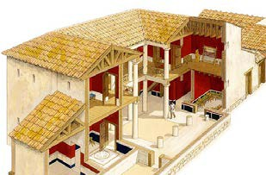
Figure 7.11 Some Greek homes and palaces had what we consider modern-day comforts, such as indoor plumbing and drainage systems.

Farming
Even in the city-states, up to 90 percent of the people lived by farming. Their year followed a regular routine, divided not by months but by seasons. The major events were harvesting grain in May, grapes in September, olives in
November, and ploughing and sowing the fields in October and November.
They grew wheat to make flour for bread. Barley grew well because it was suited to Greece’s dry climate and poor soil. Wealthy Greeks regarded barley as a food for animals, slaves, and the poor.
A typical farm was very small by our standards. It had a fruit and vegetable garden, some chickens and pigs, grapevines, a few olive trees, and barley growing among the trees.
The soil was thin, and rocks showed through in many places. Sometimes, the rocks were gathered into piles and used as sacred markers. A farm might also have some beehives; the Greeks used honey as we use sugar.

12 World History: Societies of the Past

Our word history comes from the Greek word historia, which originally meant
“research” or “inquiry” and came to mean “knowledge.”

Cattle were a rare luxury, and only the rich owned horses. Oxen were used for hard farm work, such as ploughing. They were stronger and less expensive than horses. When oxen died, their hides were turned into leather. People ate their meat, and used sinew for twine and fat for candle tallow. Herders looked after flocks of sheep and goats on the mountainsides.
For hauling and carrying, farmers used oxen, mules, and donkeys.
Most of the farm work was done by human labour, and most farmers owned one or two slaves to help them with the work. As they do today, women took an active part in the farm work. Farm wives could not afford to stay indoors as did the women from wealthy families in the cities.
Farmers produced many materials used by city artisans and craftspeople. These materials included leather, wood, flax to make linen, and horns and bone for glue.

What They Ate
In ancient Greece, breakfast was very light, usually a drink of water and perhaps some fruit, if it was in season, or a small piece of bread. Lunch was also a light meal. Once again, the beverage was water. Lunch included bread and fruit or vegetables. The most widely eaten vegetables were lentils, peas, beans, onions, and garlic, while the most common kinds of
fruit were grapes, apples, figs, dates, and melons. Nuts, olives, and eggs were also popular. The main meal was eaten in the evening and usually included wine mixed with water and some kind of broth. In areas near the sea, such as Athens, people ate fish.
Meat was reserved for special occasions and was often from animals that had been sacrificed in religious
ceremonies. Cheese made from the milk of sheep or goats was also common. By our standards, the Greeks ate very simply. Many of the staple foods that we take for granted were unknown to the Greeks, including rice, potatoes, sugar, pasta, tea, coffee, bananas, and many other fruits and vegetables.
Men of wealth hunted deer and other animals for sport. Poorer people used snares and slings to hunt small birds and rabbits for meat for their families.

What They Wore
Most men and women wore a rectangle of cloth arranged around the body as a tunic or robe and fastened at the shoulder. It was called the chiton [KIE-ton]. A man’s chiton was shorter than a woman’s.
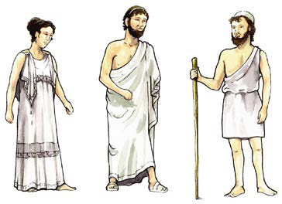
If underwear was worn at all, it was simply another piece of cloth arranged around the body. In cold weather, the Greeks wore cloaks. The only kind of footwear was leather sandals, although many people would also go barefoot.

Figure 7.12 Both men and women wore loose tunics called a
chiton. Younger men often wore a short tunic.

Ancient Greece 13

